ASSIGNMENT 3
Food Delivery Rating Analyzer
Unit – Arrays and Methods | Individual Coding Assignment

Student Name | Sasanka Sekhar Kundu
Assignment | Assignment 3 – Food Delivery Rating Analyzer
Programming Language | Java
IDE Used | Visual Studio Code

1. Objective
The objective of this assignment is to develop a Java program that analyzes customer ratings of five food delivery partners across four parameters: Delivery Speed, Food Quality, Packaging, and Service. The program uses arrays and methods to calculate totals and averages, performs a linear search, and ranks partners using Bubble Sort.

2. Problem Statement
Develop a Java program that stores food delivery partner ratings in a 2-D array, calculates the total and average rating for each partner, searches for a specified rating value, sorts partners from highest to lowest total rating, and identifies the highest-rated partner.

3. Sample Rating Data
Partner | Speed | Quality | Packaging | Service
Partner 1 | 4 | 5 | 4 | 5
Partner 2 | 3 | 4 | 5 | 4
Partner 3 | 5 | 5 | 5 | 5
Partner 4 | 4 | 3 | 4 | 3
Partner 5 | 5 | 4 | 5 | 4

4. Concepts Used
- Two-dimensional array for storing partner ratings
- One-dimensional array for storing total ratings
- Methods with parameter passing
- Method overloading
- Linear Search
- Bubble Sort
- Loops for array traversal
- Formatted output using printf

5. Methods Implemented
Method | Purpose
calculateTotal(int[]) | Calculates the total rating for a single partner.
calculateTotal(int[][]) | Overloaded method that calculates totals for all partners.
calculateAverage(int[]) | Calculates the average rating for a single partner.
calculateAverage(int[][]) | Overloaded method that calculates averages for all partners.
linearSearch(int[][], int) | Searches the 2-D ratings array for a specified rating.
bubbleSort(int[], int[]) | Sorts partner totals from highest to lowest while preserving partner indexes.

6. Complete Source Code
public class FoodDeliveryRatingAnalyzer {
// Calculate total rating for one partner
public static int calculateTotal(int[] ratings) {
int total = 0;
for (int rating : ratings) {
total += rating;
}
return total;
}
// Overloaded method: calculate totals for all partners
public static int[] calculateTotal(int[][] ratings) {
int[] totals = new int[ratings.length];
for (int i = 0; i < ratings.length; i++) {
totals[i] = calculateTotal(ratings[i]);
}
return totals;
}
// Calculate average rating for one partner
public static double calculateAverage(int[] ratings) {
return (double) calculateTotal(ratings) / ratings.length;
}
// Overloaded method: calculate averages for all partners
public static double[] calculateAverage(int[][] ratings) {
double[] averages = new double[ratings.length];
for (int i = 0; i < ratings.length; i++) {
averages[i] = calculateAverage(ratings[i]);
}
return averages;
}
// Linear Search
public static int linearSearch(int[][] ratings, int searchValue) {
for (int i = 0; i < ratings.length; i++) {
for (int j = 0; j < ratings[i].length; j++) {
if (ratings[i][j] == searchValue) {
return i;
}
}
}
return -1;
}
// Bubble Sort: Highest total to lowest total
public static void bubbleSort(int[] totals, int[] partnerIndexes) {
for (int i = 0; i < totals.length - 1; i++) {
for (int j = 0; j < totals.length - 1 - i; j++) {
if (totals[j] < totals[j + 1]) {
int tempTotal = totals[j];
totals[j] = totals[j + 1];
totals[j + 1] = tempTotal;
int tempIndex = partnerIndexes[j];
partnerIndexes[j] = partnerIndexes[j + 1];
partnerIndexes[j + 1] = tempIndex;
}
}
}
}
public static void main(String[] args) {
String[] partners = {
"Partner 1",
"Partner 2",
"Partner 3",
"Partner 4",
"Partner 5"
};
/*
* Columns:
* 0 = Delivery Speed
* 1 = Food Quality
* 2 = Packaging
* 3 = Service
*/
int[][] ratings = {
{4, 5, 4, 5},
{3, 4, 5, 4},
{5, 5, 5, 5},
{4, 3, 4, 3},
{5, 4, 5, 4}
};
int[] totals = calculateTotal(ratings);
double[] averages = calculateAverage(ratings);
System.out.println("===== Food Delivery Rating Analysis =====");
System.out.println();
for (int i = 0; i < partners.length; i++) {
System.out.println(
partners[i] + " Total : " + totals[i]
);
System.out.printf(
partners[i] + " Average : %.2f%n",
averages[i]
);
System.out.println();
}
int searchValue = 5;
int searchResult = linearSearch(ratings, searchValue);
System.out.println("===== Linear Search =====");
System.out.println();
System.out.println("Searching for rating value : " + searchValue);
if (searchResult != -1) {
System.out.println(
"Rating " + searchValue + " found in " + partners[searchResult]
);
} else {
System.out.println(
"Rating " + searchValue + " was not found."
);
}
System.out.println();
int[] rankingTotals = totals.clone();
int[] partnerIndexes = new int[partners.length];
for (int i = 0; i < partnerIndexes.length; i++) {
partnerIndexes[i] = i;
}
bubbleSort(rankingTotals, partnerIndexes);
System.out.println("===== Ranking =====");
System.out.println();
for (int i = 0; i < partnerIndexes.length; i++) {
int partnerIndex = partnerIndexes[i];
System.out.println(
(i + 1) + ". " + partners[partnerIndex]
);
}
System.out.println();
int highestPartnerIndex = partnerIndexes[0];
System.out.println(
"Highest Rated Partner: " + partners[highestPartnerIndex]
);
System.out.println(
"Highest Total Rating: " + rankingTotals[0]
);
}
}

7. Calculations
Partner 1 Total = 4 + 5 + 4 + 5 = 18; Average = 18 / 4 = 4.50
Partner 2 Total = 3 + 4 + 5 + 4 = 16; Average = 16 / 4 = 4.00
Partner 3 Total = 5 + 5 + 5 + 5 = 20; Average = 20 / 4 = 5.00
Partner 4 Total = 4 + 3 + 4 + 3 = 14; Average = 14 / 4 = 3.50
Partner 5 Total = 5 + 4 + 5 + 4 = 18; Average = 18 / 4 = 4.50

8. Search and Ranking
A Linear Search is used to find the rating value 5 in the two-dimensional array. The search successfully finds the value in Partner 1. Bubble Sort is then applied to the total-rating array in descending order. Partner indexes are swapped together with their totals so that the ranking remains associated with the correct delivery partner.
Final ranking:
1. Partner 3
2. Partner 1
3. Partner 5
4. Partner 2
5. Partner 4
Highest Rated Partner: Partner 3
Highest Total Rating: 20

9. Compilation and Execution
The program was compiled and executed successfully in the VS Code terminal using:
javac FoodDeliveryRatingAnalyzer.java
java FoodDeliveryRatingAnalyzer

10. Test Run / Output
===== Food Delivery Rating Analysis =====
Partner 1 Total : 18
Partner 1 Average : 4.50
Partner 2 Total : 16
Partner 2 Average : 4.00
Partner 3 Total : 20
Partner 3 Average : 5.00
Partner 4 Total : 14
Partner 4 Average : 3.50
Partner 5 Total : 18
Partner 5 Average : 4.50
===== Linear Search =====
Searching for rating value : 5
Rating 5 found in Partner 1
===== Ranking =====
1. Partner 3
2. Partner 1
3. Partner 5
4. Partner 2
5. Partner 4
Highest Rated Partner: Partner 3
Highest Total Rating: 20

11. Execution Screenshot
The following screenshot shows the FoodDeliveryRatingAnalyzer source code in Visual Studio Code and the successful terminal execution, including totals, averages, Linear Search, ranking, and the highest-rated partner.
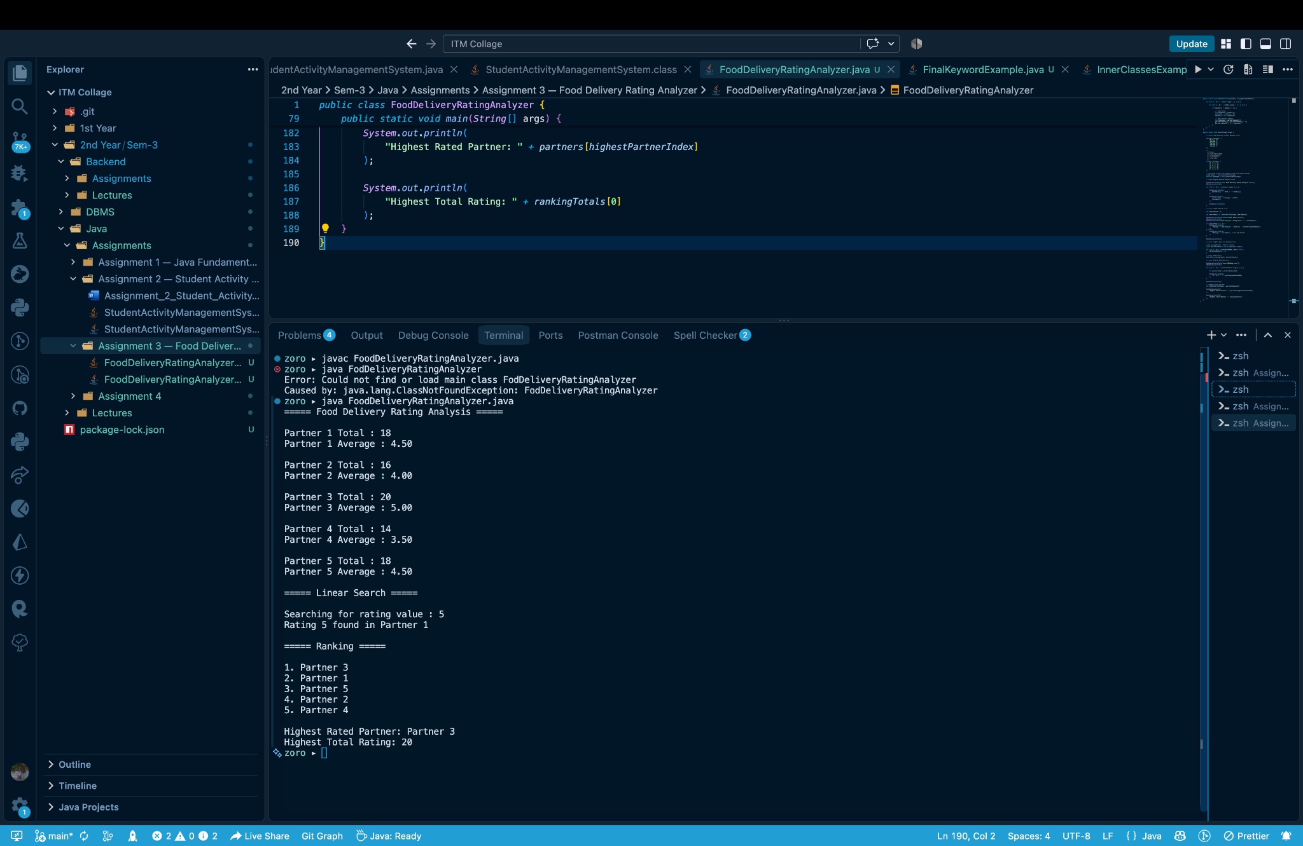

12. Result
The Food Delivery Rating Analyzer was successfully compiled and executed. The program correctly stored the ratings in a 2-D array, calculated totals and averages using overloaded methods, performed a Linear Search, applied Bubble Sort for descending ranking, and identified Partner 3 as the highest-rated delivery partner with a total rating of 20.

13. Conclusion
This assignment provided practical experience in using Java arrays and methods to process structured data. It demonstrated parameter passing, method overloading, searching, sorting, and formatted output. The successful execution confirms that the program satisfies the specified assignment requirements.
— End of Assignment 3 Report —

